

For a given input string “Python is a case sensitive language”. Write python code for the following:

a. Find the length of the input string.

b. Reverse the order of the string in one line code.

c. Using Slice function store “a case sensitive” in new string.

d. Replace “a case sensitive” with “object oriented”.

e. Find index of substring “a” in the given input string.

f. Remove the white spaces from the given input string.

**CODE:**

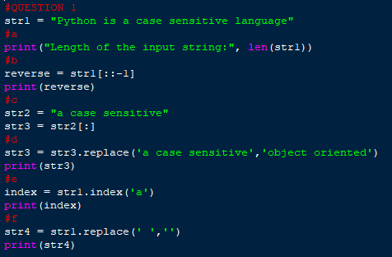

**OUTPUT:**

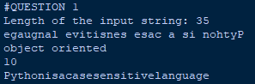

Store your name, SID, department name and CGPA into different variables.

With the help of String formatting print the following output:

Hey, ABC Here!

My SID is 2110XXXX

I am from XYZ department and my CGPA is 9.9

**CODE:**

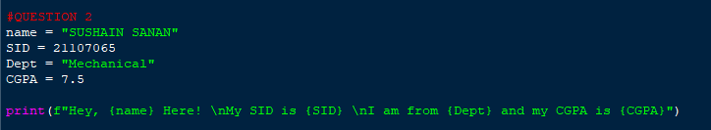

**OUTPUT:**

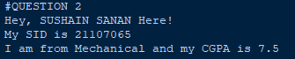

For a=56 and b=10 with the help of bitwise operators calculate the following:

a. a&b

b. a|b

c. a^b

d. Left shift both a and b with 2 bits.

e. Right shift a with 2 bits and b with 4 bits.

**CODE:**

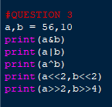

**OUTPUT:**

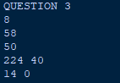

Write a python program to check if the word “name” is present in the string

entered by the user (Print : “Yes” or “No”).

**CODE:**

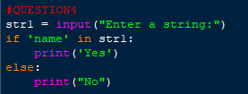

**OUTPUT:**



For any three lengths, there is a simple test to see if it is possible to form a

triangle. If any of the three lengths is greater than the sum of the other two,

then you cannot form a triangle. Otherwise, Enter three sides of a triangle,

converts them to integers, and to check whether the given input lengths can

form a triangle or not (Print : “Yes” or “No”).[Don’t use if else here].

**CODE:**

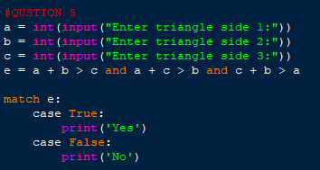

**OUTPUT:**

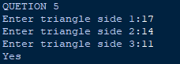

Given two numbers ‘a’ and b’. Write a program to count number of bits

needed to be flipped to convert ‘a’ to ‘b’.

**CODE:**

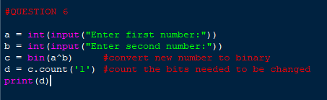

**OUTPUT:**

